2026 Term 1 Grade Four
Indigenous Languages Schemes Of Work
Term One Year School

Wee k | Ls n | Strand/Theme | Sub strand | Specific learning outcomes | Key inquiry Questions | Learning experiences | Learning Resources | Assessmen t methods | Refl
1 | 1 | Listening | 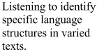 | 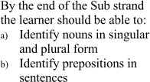 | 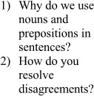 | 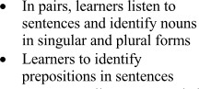 | 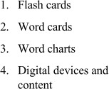 | Observatio n, QA,  Digital assessment
 | 2 |  |  | 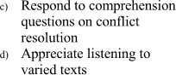 |  | 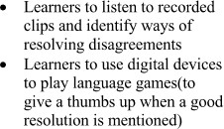 |  | Observatio n, QA,  Digital assessment
2 | 1 |  | 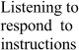 | 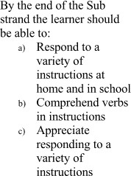 | 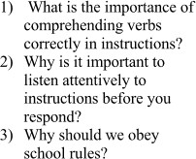 | 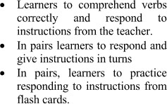 | 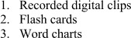 | Observatio n, QA,  Digital assessment

 | 2 |  |  |  |  | 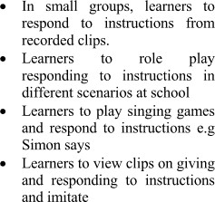 |  | Observatio n, QA,  Digital assessment
3 | 1 |  | 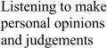 | 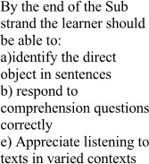 |  | 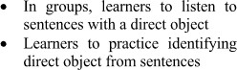 | 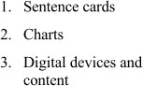 | Observatio n, QA,  Digital assessment
 | 2 |  |  |  |  |  |  | Observatio n, QA,  Digital assessment
4 | 1 |  |  |  | 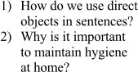 | 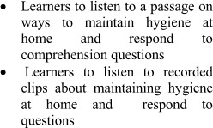 |  | Observatio n, QA,  Digital assessment
 | 2 |  | 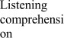 | 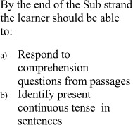 | 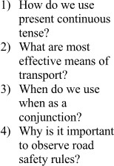 | 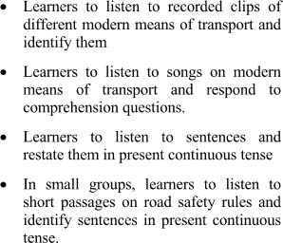 |  | Observatio n, QA,  Digital assessment
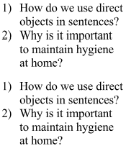
5 | 1 |  |  | 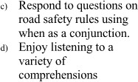 |  | 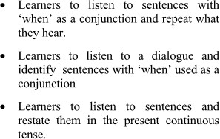 |  | Observatio n, QA,  Digital assessment
 | 2 |  | 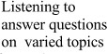 | 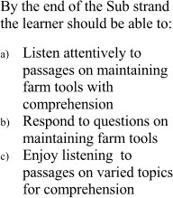 | 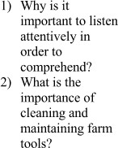 | 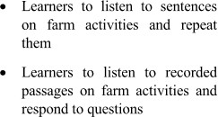 | 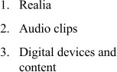 | Observatio n, QA,  Digital assessment
6 | 1 |  |  |  |  | 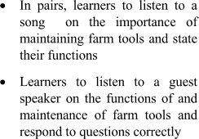 |  | Observatio n, QA,  Digital assessment

 | 2 |  | 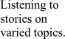 | 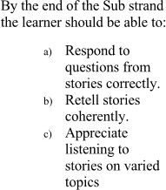 | 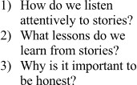 | 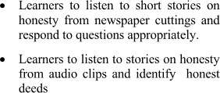 |  | Observatio n, QA,  Digital assessment
7 | 1 |  |  |  |  | 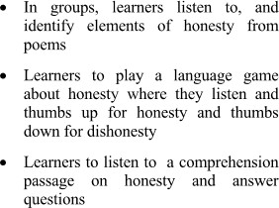 |  | Observatio n, QA,  Digital assessment
 | 2 |  | 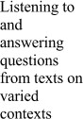 | 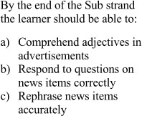 | 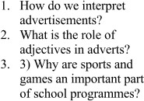 | 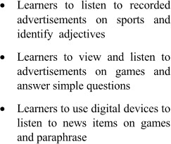 | 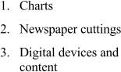 | Observatio n, QA,  Digital assessment

8 | 1 |  |  | 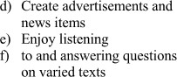 |  | 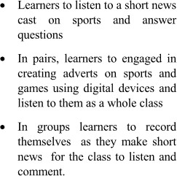 |  | Observatio n, QA,  Digital assessment
 | 2 |  | Listening to a variety of moral short stories | 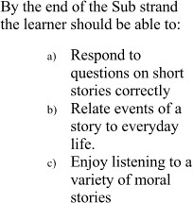 | 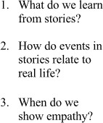 | 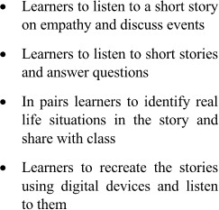 | 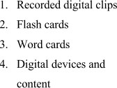 | Observatio n, QA,  Digital assessment
9 |  |  |  | Half term 1
10 | 1 |  | Listening to a variety of moral short stories |  |  |  |  | Observatio n, QA,  Digital assessment

 | 2 |  | Listening to narration with cultural language use | 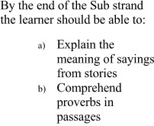 | 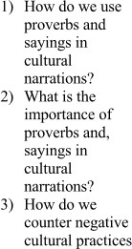 | 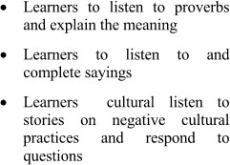 | 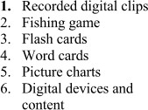 | Observatio n, QA,  Digital assessment
11 | 1 |  | Listening to narration with cultural language use | 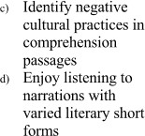 |  | 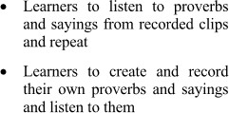 |  | Observatio n, QA,  Digital assessment
 | 2 |  | Listening to conversations | 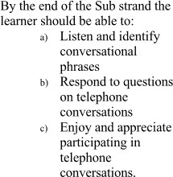 | 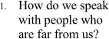 | 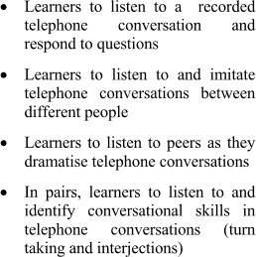 | 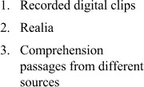 | Observatio n, QA,  Digital assessment

12 | 1 |  | Listening to comprehensio n passages on buying and selling | 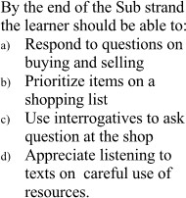 | 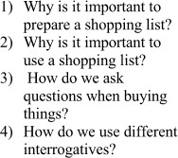 | 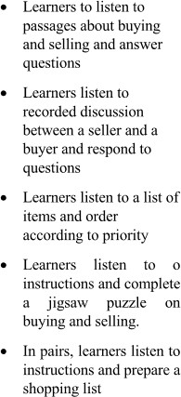 | 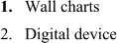 | Observatio n, QA,  Digital assessment
 | 2 |  | Listening to dialogues on varied topics | 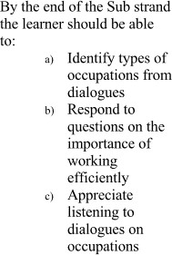 | 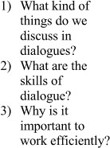 | 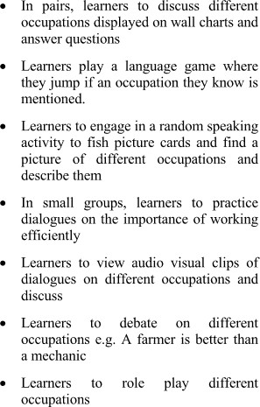 | 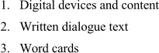 | Observatio n, QA,  Digital assessment
13 |  |  |  | End term assessment

